Assignment 24.6

1. Write a hive query to find the minimum temperature observed in a given weather station in a particular year.

First creating the table as temp then loading given dataset into the table and finally finding minimum temperature using MIN function.

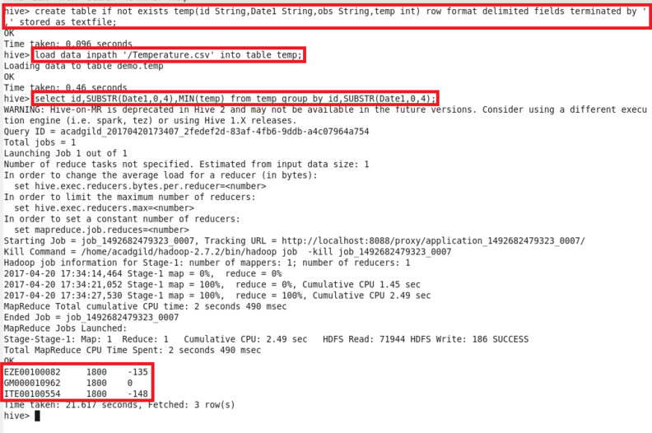

1. Write a hive query to find the maximum temperature observed in a given weather station in a particular year.

Here, finding maximum temperature using MAX function and displaying the output.

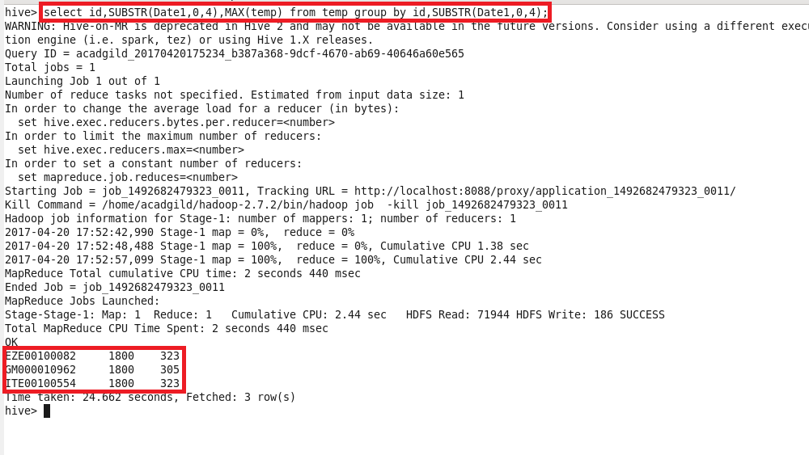

1. Write a hive query to find the number of readings given by each weather station according to the dataset.

Here, finding number of temperature readings using COUNT function and displaying the output.

